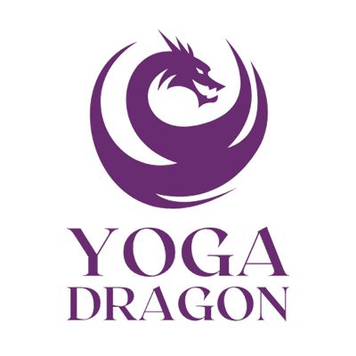

CHAIR AND VINYASA FLOW YOGA CLASSES
ARE CONTINUING IN
GIFFORD AND GARVALD OVER THE SUMMER

Already coming to Yoga Dragon’s classes – let’s keep the momentum and progress moving forward, by carrying on over the summer.
If your regular class is having a summer break, feel free to join us to fill in that gap.
Never been before and have some time to try it out over the summer – you are very welcome to drop in and give it a go.
Whatever the reason, book now to secure a space www.yoga-dragon.co.uk
or contact
kirsty@yoga-dragon.co.uk

GIFFORD – Wednesday 10am to 11am – Chair Class, Gifford Bowling Club.
Wednesday 7pm to 8pm – Flow Yoga, Gifford Village Hall.

GARVALD – Thursday 9.30am to 10.30am – Chair Class, Garvald Village Hall.
Thursday 6.30pm to 7.30pm – Vinyasa Flow, Garvald Village Hall.

